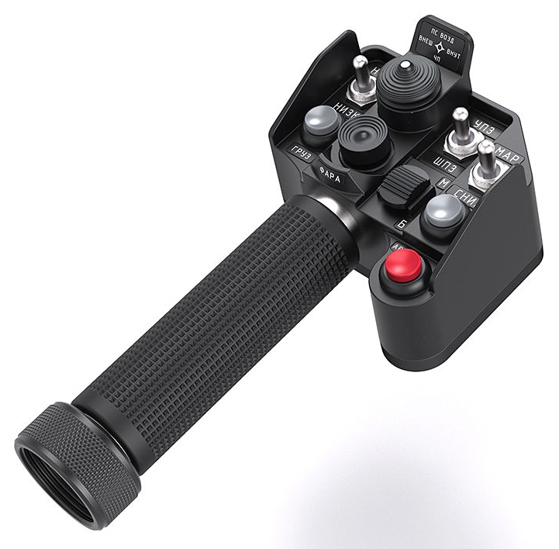
105 - Controls - Gunner - Collective Grip Alpha-L
U=Up, D=Down, F=Forward, B=Backward, L=Left, R=Right, P=Press, S-*=Shift-*, L-*=Long-*

Trigger
- P1: Cursor enter
- P2: --
Flip-down Trigger
- P: --
Top hat -- FCR scan size, Cued search
- P: Cued search (slew FCR to detected emitter)
- U: FCR Zoom
- D: FCR Medium
- R: FCR Wide
- L: FCR Narrow
Middle hat -- Select sight, FCR scan, (shifted) FCR mode
- U: HMD (IHADSS)
- D: Link -- Sets FCR or TADS to direction of TADS or FCR, depending on which sight is selected
- L: FCR
- R: TADS
- P: FCR scan
- S-U: FCR GTM (Ground Target Mode)
- S-D: FCR ATM (Air Target Mode)
- S-R: FCR RMAP (Radar Map mode)
- S-L: FCR TPM (Terrain Profiles Mode)
Ministick
- Axes: Cursor controller
- P: Cursor enter
Thumb hat -- Comms
- L: (SRS radio 1 PTT)
- R: (SRS radio 2 PTT)
- D: (SRS radio 3 PTT)
- S-L: Radio 1 PTT (opens comms menu for radio 1)
- S-R: Radio 2 PTT (opens comms menu for radio 2)
- P: (VoiceAttack PTT)
- S-P: (VoiceAttack center mouse cursor)
Index finger hat -- NVS Select, Cursor Display Select, (shift) Stabilator control
- U: TADS
- D: PNVS
- P: Cursor Display Select -- Cycles the Cursor Controller between displays.
- S-U: Manual stabilator nose down
- S-D: Manual stabilator nose up
- S-P: Stabilator auto mode
Red Button -- Countermeasures
- P: Chaff
Black Button -- Countermeasures
- P: Flares
Scroll Wheel
- F: --
- B: --
- P1: --
- P2: --
Brake lever
- Axis: --
- P: --
Pinky button
- P: Wheel brakes (toggle)
- S-P: Tail Wheel lock/unlock

